PUE:

Dale (Zayo) Dale: Virtual containerization work-in-progress, not done yet. Cross-connect – only human resource remediation.

* Not tracking PUE
* Started ESG committee, DC and network carbon footprint (setting up by end of Q321)
* California starting now to require Telecom providers to start tracking carbon footprint
* Struggling to get carbon footprint optimization across 30,000 buildings

Jim: 2MW max; 800kW current

* Everyone measures PUE somewhat differently (e.g., lights)
* Benefit of Vigilant increased PUE, but not currently not fully utilized DC

0 to 100 in 6 months

* No standardization of design

Dale: 2 things drive

1. Based on asset life (end of life)
2. Not standard due to soverenty issues (ex: India, they require access)

Paul: Eastern Asia has different cost models, so hard to standardize

* Minority workforce is an entrypoint

Dale: Edge DC: Data center in a box – effort to simplify

* Requirements are different country to country

Cyber Security is a mega point on slide 7 (goal zero hacks). DC community take bolt-on approach, not good enough

Takeaways: Add security, standardization

===

Dan Loosemore – DCD COO (Keynote speaker)

DCD: 7m members, 300k newsletter

* HON commissioned study in May 2021
* Huge increase in sustainability searches on DCD web site
* Executive leadership is key driver of sustainability; next facilities and IT depts
  + VP Hyundai has partnership sustainability as a KPI
* Needs measurements beyond PUE for it to be successful
* Main driver for 48% of responses is economic gain, then for corp brand
* Trend is clear: sustainability becoming very important in 3 years (80% of responses)
* Hyperscale investing despite cost; others will pay a small premium
* Bloom Energy: Fuel cell ROI: 5 yr for small deployment, 10 yr for large deployment
* 66% believe PUE should be replaced w/a better metric
* 35% believe investment and incentives necessary for net-zero
* Biggest impacts:
  + Energy source 83%
  + Improve IT utilization 72%
  + Natural air free cooling 68%
* DC CAGR, 20%+ LATAM
* Lead-times decreasing (building faster, cheaper)
* On-prem is flat

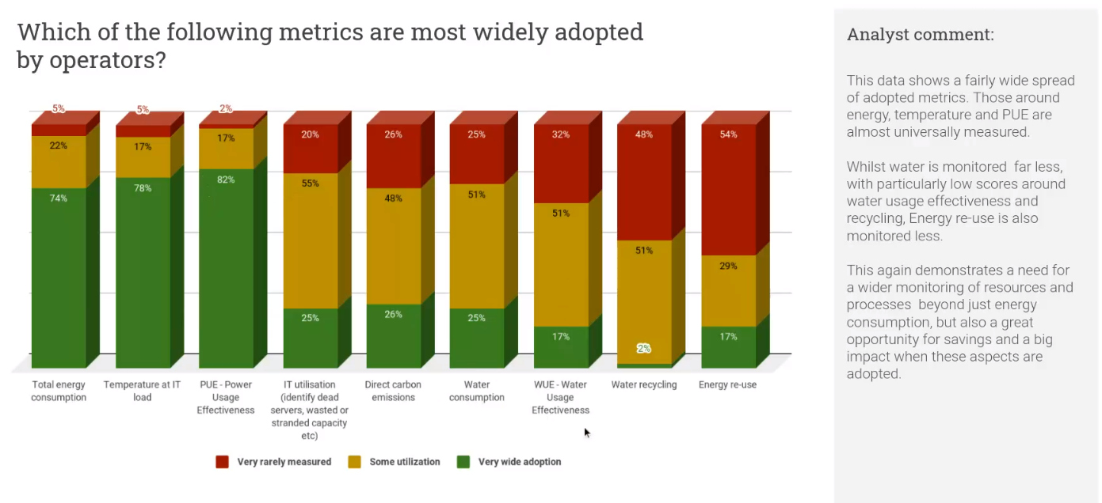

Suggestions for improvement:

Gary: 2-2.5 hours is sweet spot. Outside speaker for 30 mins is great. More meaningful panel/debate over thought-provoking topics.

Mark: Good to have telco. Would like hyperscale and enterprise guest.

James: reserve time for other companies to spotlight/products

Dale: Same as James above. See other guest views of the future of DC.

Sabi: Next CAB in Sep/Oct ’21.