The Saia PCD3.M6893: the gateway to a new generation of PCD technology

- Reliable control with cyber security
- Object-oriented high-level language programming
in accordance with IEC 61131-3
- Can be expanded with the existing Saia PCD3 I/O system

Murten, March 2019 – With the new IEC controller, Saia Burgess Controls (SBC) is presenting he gateway to a new generation of PCD technology. The prototype unveiled at the ISH fulfils the strictest cyber security requirements and boasts object-oriented high-level language programming. As usual, the hardware remains compatible with the previous I/O and communication modules.

When developing the Saia PCD3.M6893, the focus was on cyber security and reliability. The IEC controller conforms to Cyber Secure Level 3 based on the industrial security standard ANSI ISA 62443-1-1; an update to Level 4 will take place in due course. It is therefore also suitable for use in systems that are subject to special regulations. The standardised security level makes it easier for government and supervisory authorities to carry out audits.

Standard interfaces make integration easier
The new controller has two Ethernet interfaces, CAN, two serial communication interfaces, a USB host and a large data and application memory (Micro-SD).

Encrypted and signed
The operating system including data, the application program and communication is encrypted and signed and thus protects the operator reliably against unauthorised access to data and process control. The IEC controller is programmable in accordance with the IEC 61131-3 industrial standard for application development and makes engineering easier for application programmers. Existing program parts from existing control systems which comply with IEC 61131-3 can be imported and benefit from the IEC controller’s high security standard.

Automation is becoming cloud-capable
All languages defined in the IEC standard are supported (function block, sequential functions, structured text including object-oriented programming). In addition, the PCD3.M6893 connects the automation with the cloud and its services for analysis and optimisation. Because it is compatible with the existing Saia PCD I/O system, existing systems can be securely connected to the cloud and IoT (Internet of Things) services.

Sturdy, flexible, versatile
The freely programmable Saia PCD3 range is designed for demanding automation tasks. Its sturdy cassette design as well as the integrated communication interfaces and numerous expansion options make it very versatile. Thanks to the CPU’s generous memory resources, data and statuses can be recorded, monitored, archived and controlled up to a certain point without a visualisation/SCADA system.

Images (SBC, no charge for reproduction when source is cited):
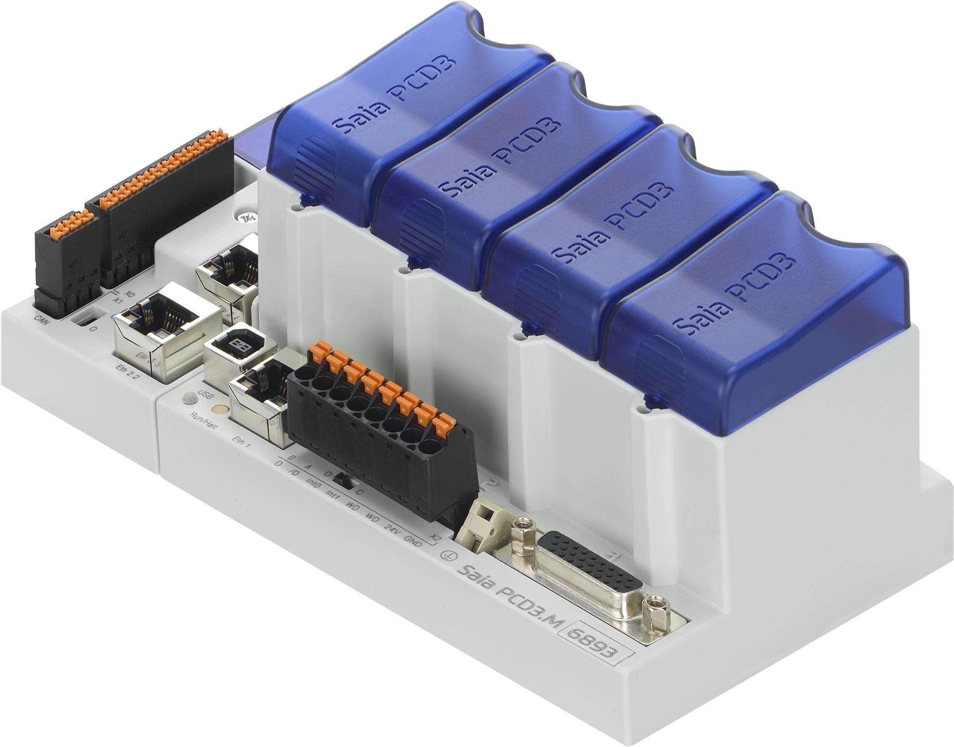 | With the IEC controller, SBC now offers a gateway to a new generation of PCD technology.  The PCD3.M6893 offers the very highest level of cyber security and object-oriented high-level language programming.

More press materials can be found at https://www.saia-pcd.com/de-de/service/presse/

About Saia-Burgess Controls AG:
Saia-Burgess Controls AG (www.saia-pcd.com) is a wholly-owned subsidiary of the Honeywell Group. SBC has developed, produced and marketed electronic components and measurement and control systems since 1978. The products have an extremely long service life with a life cycle of up to 25 years and are mainly used in heating, ventilation, air conditioning, energy management and water systems. A further important pillar is OEM production. SBC produces around 2 million I/O points, 35,000 CPUs and more than 700,000 small devices each year to the most exacting quality standards. With annual turnover of €68 million and more than 200 employees, the Swiss company headquartered in Murten is a valued manufacturer of infrastructure automation

solutions.
Saia-Burgess Controls AG Ansel & Möllers GmbH
Press office PR agency
Bahnhofstrasse 18 König-Karl-Str. 10
3280 Murten 70372 Stuttgart
Switzerland Germany

T +41 26 580 30 00 T +49 711 925 45 0
presse@saia-pcd.com s.setka@anselmoellers.de
www.saia-pcd.com www.anselmoellers.de

SBC Deutschland GmbH
Strahlenbergerstraße 110–112
63067 Offenbach am Main

T +49 69 806 40 40
marketing.de@saia-pcd.com
www.saia-pcd.de

